USB TO RS232 CONVERTER

GENERAL DESCRIPTION

There are a lot of devices out there that still communicate over RS232 but we bet your new laptop isn’t one of them. Don’t worry, though, we’ve got you covered. This 6ft converter plugs into your computer’s USB port and provides you with a DB-9 RSR232 connection. After installing the drivers onto your Windows, Mac or Red Hat Linux system, the FTDI chipset inside the cable will enumerate as a COM port with a baud rate adjustable to whatever setup you want to connect to RS232. We were curious what made this cable work, so we tore one open and found that it’s simply an FTDI FT232 paired with a Zywyn, ZT213 RS232 Transceiver.

PRODUCT DESCRIPTION

The USB_RS232 cables are a family of USB to RS232 levels serial UART converter cables incorporating FTDI’s FT232RQ USB to serial UART interface IC device which handles all the USB signaling and protocols. The cables provide a fast, simple way to connect devices with a RS232 level serial UART interface to USB. Each USB-RS232 cable contains a small internal electronic circuit board, utilizing the FT232R, which is encapsulated into the USB connector end of the cable. The integrated electronics also include the RS232 level shifter plus Tx and Rx. LEDs which give a visual indication of traffic on the cable.

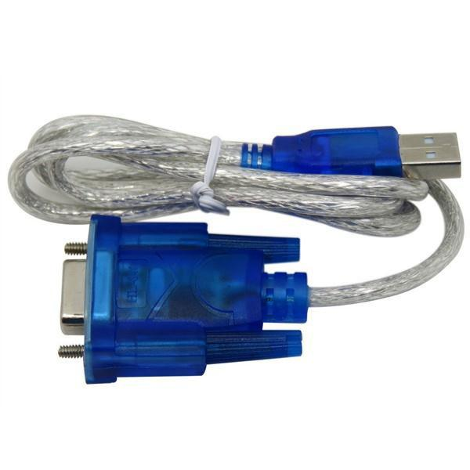

USB to RS232 convertor

FEATURES

- USB Chip: CH340

- Connector: DB9 Male - all signals

- Cable Length: 0.8 meters

- Wire: Shielded

- Body: Dust Proof fully molded enclosure

APPLICATIONS

- USB to serial RS232 level converter

- Upgrading legacy peripherals to USB

- Interface Microcontroller UART or I/O to USB

- Interface FPGA or PLD to USB

